Descarga e instalación de Raspian

<https://desertbot.io/blog/headless-raspberry-pi-4-ssh-wifi-setup>

Raspbian Buster lite

<https://downloads.raspberrypi.org/raspbian_lite_latest>

cargar desde USB:

<https://www.nociones.de/como-arrancar-la-raspberry-pi-3-desde-un-usb/>

Habilitar cámara:

pi@raspberrypi:~ $ sudo raspi-config

5 Interfacing Options Configure connections to peripherals

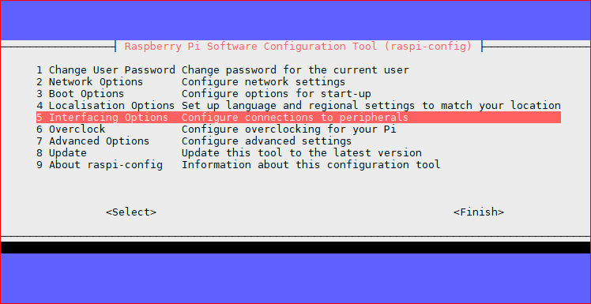

P1 Camera Enable/Disable connection to the Raspberry Pi Camera

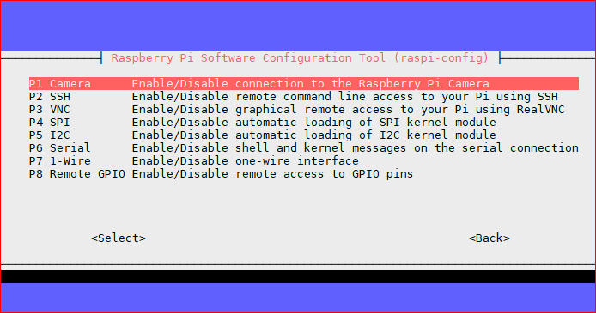

REINICIAR

Resize SD Card:

7 Advanced Options Configure advanced settings

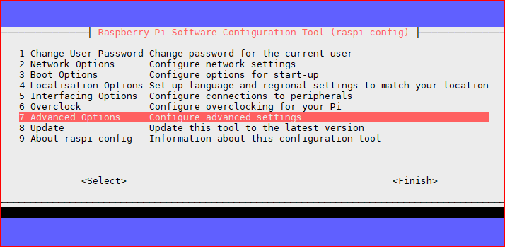

A1 Expand Filesystem Ensures that all of the SD card storage is available to the OS

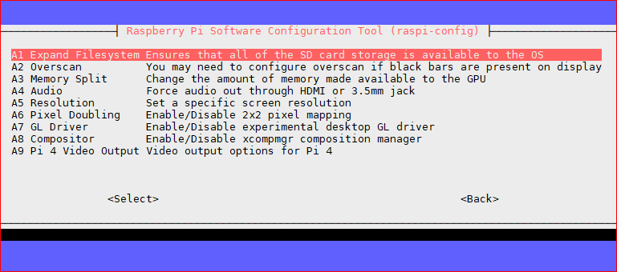

<https://hardzone.es/2018/08/25/como-configurar-modulo-camara-raspberry-pi-3/>

Forma correcta de conectar la cámara:

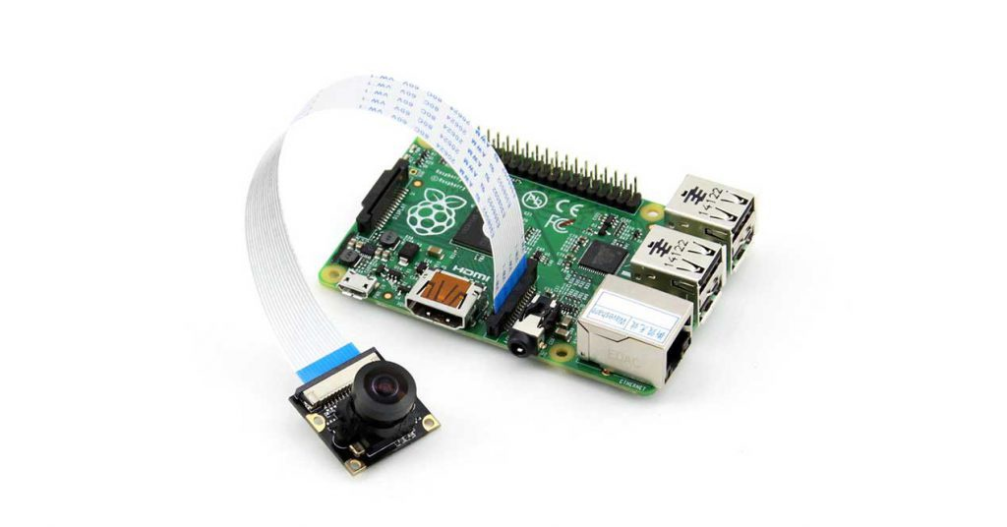

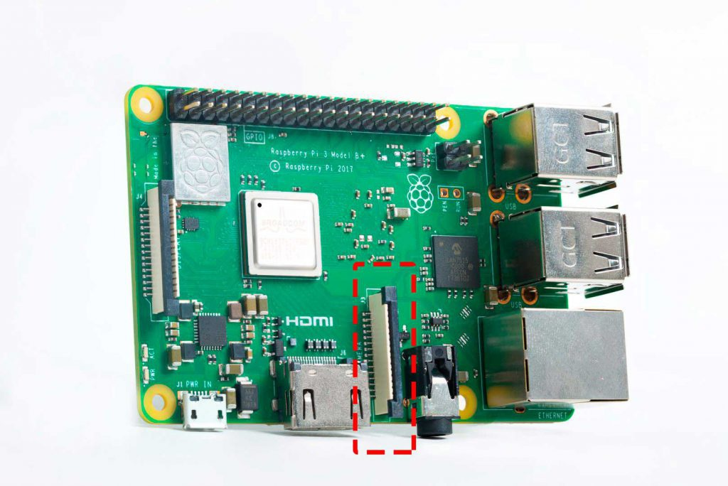

INSTALACIÓN DE SOFTWARE:

pi@raspberrypi:~ $ sudo apt update && sudo apt upgrade

pi@raspberrypi:~ $ sudo apt install motion

sudo nano /etc/default/motion

start_motion_daemon=yes

sudo nano /etc/motion/motion.conf

daemon on

stream_localhost off

webcontrol_port 8080

output_pictures on

# target_dir /var/lib/motion

target_dir /media/PenDrive

stream_port 8081

stream_maxrate 20

sudo /etc/init.d/motion start

sudo /etc/init.d/motion status

configuraciones varias motion:

<https://gist.github.com/richardhawthorn/72db3366d9824a3ed85de852bdb5ce0f>

<https://geekland.eu/sistema-de-videovigilancia-motion/>

configurar USB para poner imágenes:

Localizar usb:

pi@raspberrypi:~ $ df -h

Filesystem Size Used Avail Use% Mounted on

/dev/root 3.4G 1.4G 1.9G 43% /

devtmpfs 181M 0 181M 0% /dev

tmpfs 185M 0 185M 0% /dev/shm

tmpfs 185M 7.3M 178M 4% /run

tmpfs 5.0M 4.0K 5.0M 1% /run/lock

tmpfs 185M 0 185M 0% /sys/fs/cgroup

**/dev/sda1 3.7G 20M 3.5G 1% /media/PenDrive**

/dev/mmcblk0p1 253M 40M 214M 16% /boot

tmpfs 37M 0 37M 0% /run/user/1000

sudo umount /dev/sda1

sudo mkfs.ext4 /dev/sda1 -L capturas

Montar unidad:

pi@raspberrypi:~ $ sudo blkid -o list

device fs_type label mount point UUID

-------------------------------------------------------------------------------------------------------------------------------------------------------------

/dev/mmcblk0p1 vfat boot /boot F661-303B

/dev/mmcblk0p2 ext4 rootfs / 8d008fde-f12a-47f7-8519-197ea707d3d4

**/dev/sda1 ext4 capturas /media/PenDrive f46c2dc2-8b58-4615-b8b1-2ffd57bc55cd**

/dev/mmcblk0

pi@raspberrypi:~ $ sudo nano /etc/fstab

proc /proc proc defaults 0 0

PARTUUID=b4131aef-01 /boot vfat defaults 0 2

PARTUUID=b4131aef-02 / ext4 defaults,noatime 0 1

# a swapfile is not a swap partition, no line here

# use dphys-swapfile swap[on|off] for that

UUID=f46c2dc2-8b58-4615-b8b1-2ffd57bc55cd /media/PenDrive ext4 defaults 0

pi@raspberrypi:~ $ sudo mount -a

Apagar el led de la cámara:

<https://www.raspberrypi-spy.co.uk/2013/05/how-to-disable-the-red-led-on-the-pi-camera-module/>

pi@raspberrypi:~ $ echo disable_camera_led=1 | sudo tee -a /boot/config.txt